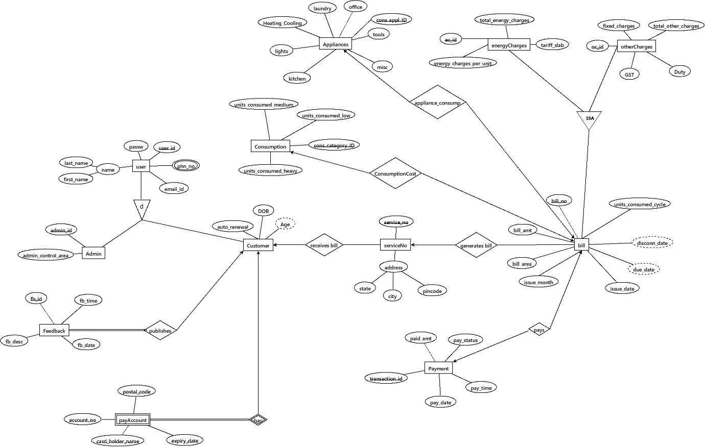

**Master Schema:**

Electricity_Billing (user_id, admin_id, fb_id, service_no, transaction_id, bill_no, oc_id, ec_id, cons_appl_ID, cons_category_ID, passw, phn_no, email_id, first_name, last_name, admin_control_area, auto_renewal, DOB, fb_time, fb_desc, fb_date, postal_code, account_no, card_holder_name, expiry_date, state, city, pincode, paid_amt, pay_status, pay_date, pay_time, bill_amt, bill_area, issue_month, issue_date, units_consumed_cycle, total_other_charges, fixed_charges, GST, Duty, total_energy_charges, tarrif_slab, energy_charges_per_unit, office, laundry, Heating_Cooling, lights, kitchen, misc, tools, units_consumed_heavy, units_consumed_medium, units_consumed_low)

**1NF:**

1. The relation has primary keys.
2. phn_no is a multivalued attribute, so it can be flattened out.
3. There are no repeating groups.

**Functional dependencies:**

* user_id, phone_no → first_name, last_name, passw, email_id, phone_no, DOB
* user_id → auto_renewal, postal_code, account_no, card_holder_name, expiry_date
* admin_id, user_id → admin_control_area
* fb_id, user_id → fb_time, fb_date, fb_desc
* service_no → state, city, pincode
* pincode → city, state
* transaction_id → pay_time, pay_date, pay_status, paid_amt
* bill_no, user_id → bill_amt, bill_area, issue_month, issue_date, paid_amt, pay_time, pay_date, pay_status, transaction_id
* bill_no → units_consumed_cycle, oc_id, ec_id, cons_appl_id, cons_category_id, fixed_charges, total_other_charges, GST, Duty, tariff_slab, total_energy_charges, energy_charges_per_unit, office, tools, misc, kitchen, lights, Heating_Cooling, laundry, units_consumed_heavy, units_consumed_medium, units_consumed_low
* oc_id → fixed_charges, total_other_charges, GST, Duty
* ec_id → total_energy_charges, energy_charges_per_unit, tariff_slab
* cons_appl_id → office, tools, misc, kitchen, lights, Heating_Cooling, laundry
* cons_category_id, bill_no → units_consumed_heavy, units_consumed_medium, units_consumed_low

**2NF:**

1. The table is in 1NF.
2. Partial dependencies exist.

Master schema can be decomposed as:

Customer(user_id, auto_renewal, postal_code, account_no, card_holder_name, expiry_date), with FDs:  
user_id → auto_renewal, postal_code, account_no, card_holder_name, expiry_date

user_details (user_id, phone_no, DOB, first_name, last_name, passw, email_id), with FDs:  
phone_no, user_id --> first_name, last_name, passw, email_id

Admin (admin_id, user_id, admin_control_area), with FDs:  
admin_id, user_id --> admin_control_area

Service(service_no, pincode, state, city) with FDs:

service_no --> pincode

pincode --> city, state

Bill(bill_no, units_consumed_low, units_consumed_medium, units_consumed_heavy, tools, misc, kitchen, lights, Heating_Cooling, laundry, office, energy_charges_per_unit, tarrif_slab, total_energy_charges, Duty, GST, total_other_charges, fixed_charges, cons_category_ID, cons_appl_ID, ec_id, oc_id, units_consumed_cycle) with FDs:

bill_no → units_consumed_cycle, oc_id, ec_id, cons_appl_id, cons_category_id, fixed_charges, total_other_charges, GST, Duty, tariff_slab, total_energy_charges, energy_charges_per_unit, office, tools, misc, kitchen, lights, Heating_Cooling, laundry, units_consumed_heavy, units_consumed_medium, units_consumed_low

oc_id, bill_no → fixed_charges, total_other_charges, GST, Duty

ec_id, bill_no → total_energy_charges, energy_charges_per_unit, tariff_slab

cons_appl_id, bill_no → office, tools, misc, kitchen, lights, Heating_Cooling, laundry

cons_category_id, bill_no → units_consumed_heavy, units_consumed_medium, units_consumed_low

Payment(bill_no, user_id, transaction_id, bill_area, issue_month, issue_date, paid_amt, bill_amt, pay_status, pay_date, pay_time), with FDs:  
bill_no, user_id --> transaction_id, pay_amt, pay_date, pay_status, paid_amt, issue_date, issue_month, bill_area, bill_amt  
transaction_id --> paid_amt, pay_status, pay_date, pay_time

Feedback (fb_id, user_id, fb_desc, fb_date, fb_time), with FDs:  
fb_id, user_id --> fb_type, rating, fb_desc, fb_date, fb_time

**3NF:**

1. All relations are in 2NF.
2. Transitive dependencies exist in Service, Bill and Payment relations

Service table can be decomposed as:

Address (pincode, city, state), with FDs:  
pincode --> state, city  
  
service_details (service_no, pincode), with FDs:  
service_no --> pincode

Bill table can be decomposed as:

Energy_charge(ec_id, energy_charge_per_unit, tariff_slab, total_energy_charges) with FDs:

ec_id --> energy_charge_per_unit, tariff_slab, total_energy_charges

other_charge(oc_id, Duty, GST, fixed_charges, total_other_charges) with FDs:

oc_id --> Duty, GST, fixed_charges, total_other_charges

Appliances(cons_appl_id, office, tools, misc, kitchen, lights, Heating_Cooling, laundry) with FDs:

cons_appl_id --> office, tools, misc, kitchen, lights, Heating_Cooling, laundry

Consumption(cons_category_id, units_consumed_heavy, units_consumed_medium, units_consumed_low) with FDs:

cons_category_id --> units_consumed_heavy, units_consumed_medium, units_consumed_low

Billing(bill_no, cons_category_id, cons_appl_id, ec_id, oc_id, units_consumed_cycle) with FDs:

bill_no --> cons_category_id, cons_appl_id, ec_id, oc_id, units_consumed_cycle

Payment table can be decomposed as:

Payment_details (transaction_id, pay_amt, pay_status, pay_date, pay_time), with FDs:  
transaction_id --> pay_amt, pay_status, pay_date, pay_time  
  
Bill_details (bill_no, user_id, transaction_id, bill_area, issue_month, issue_date), with FDs:  
bill_no, user_id --> transaction_id, bill_area, issue_month, issue_date

**BCNF – Boyce-Codd normal form:**

1. All relations are in 3NF.
2. In each relation, it can be observed that the super key determines all other attributes in
3. the relation.
4. Hence, all relations are in BCNF.

**Database schema after normalisation:**

* User_details (user_id, phone_no, DOB, first_name, last_name, passw, email_id)
* customer_details (user_id, auto_renewal, postal_code, account_no, card_holder_name, expiry_date)
* Admin (admin_id, user_id, admin_control_area)
* Address (pincode, city, state)
* service_details (service_no, pincode)
* Billing(bill_no, cons_category_id, cons_appl_id, ec_id, oc_id, units_consumed_cycle)
* Energy_charge(ec_id, energy_charge_per_unit, tariff_slab, total_energy_charges)
* other_charge(oc_id, Duty, GST, fixed_charges, total_other_charges)
* Appliances(cons_appl_id, office, tools, misc, kitchen, lights, Heating_Cooling, laundry)
* Consumption(cons_category_id, units_consumed_heavy, units_consumed_medium, units_consumed_low)
* Payment_details (transaction_id, pay_amt, pay_status, pay_date, pay_time)
* Bill_details (bill_no, user_id, transaction_id, bill_area, issue_month, issue_date),
* Feedback (fb_id, user_id, fb_type, rating, fb_desc, fb_date, fb_time)